## **HOTEL BOOKING SYSTEM**

## A PROJECT REPORT

*Submitted by*

# BRIJESH.J [RA2211026010443]

# ANAMIKA SAROHA [RA2211026010393]

*Under the Guidance of*

# Dr. Usharani R

Assistant Professor, Department of Computational Intelligence

*in partial fulfillment of the requirements for the degree of*

**BACHELOR OF TECHNOLOGY**

# in

**COMPUTER SCIENCE AND ENGINEERING**



**DEPARTMENT OF COMPUTATIONAL INTELLIGENCE**

# COLLEGE OF ENGINEERING AND TECHNOLOGY

# SRM INSTITUTE OF SCIENCE AND TECHNOLOGY KATTANKULATHUR– 603 203

**MAY 2024**

i



# SRM INSTITUTE OF SCIENCE AND TECHNOLOGY

# KATTANKULATHUR–603 203

## **BONAFIDE CERTIFICATE**

**RA2211026010443, RA2211026010393** Certified to be the bonafide work done by **BRIJESH.J, ANAMIKA SAROHA** of II year/IV sem B.Tech Degree Course in the Project Course – **21CSC205P Database Management Systems** in **SRM INSTITUTE OF SCIENCE AND TECHNOLOGY**, Kattankulathur for the academic year 2023-2024.

**Date:**

### Faculty in Charge

Dr. Usharani R

Assistant Professor

Department of Computational Intelligence

SRMSIT -KTR

### HEAD OF THE DEPARTMENT

Dr. R. Annie Uthra

Professor and Head

Department of Computational Intelligence

SRMIST - KTR

### 

ii

# ABSTRACT

# This abstract presents a comprehensive overview of a proposed hotel booking system aimed at enhancing efficiency and convenience for both hoteliers and guests. In today's digital era, where seamless experiences are paramount, the need for an integrated platform that caters to the diverse requirements of hotel bookings is crucial. The proposed system incorporates advanced technological features to optimize the entire booking process, from reservation to check-out.

# Key functionalities of the system include a user-friendly interface accessible via web and mobile platforms, enabling guests to browse through available accommodations, view detailed descriptions, amenities, and pricing, and make reservations in real-time. Moreover, the system incorporates personalized recommendations based on user preferences and past booking history, enhancing the overall guest experience.

**For hoteliers, the system offers a centralized dashboard for managing room inventory, rates, and bookings, thereby streamlining operations and maximizing revenue potential. Additionally, advanced analytics tools provide valuable insights into booking trends, allowing for data-driven decision-making and targeted marketing strategies.**

**Security and data privacy are paramount considerations, and the system implements robust encryption protocols to safeguard sensitive information and ensure compliance with regulatory standards.**

# Problem Statement

# The hospitality industry faces numerous challenges in managing hotel bookings efficiently and satisfying guests' diverse needs. Traditional booking systems often lack the flexibility, speed, and personalization demanded by today's travelers, leading to inefficiencies and missed opportunities for both guests and hoteliers.

# One primary issue is the fragmentation of booking channels, including third-party booking websites, phone reservations, and walk-ins, which can result in overbooking, miscommunication, and revenue loss. Additionally, manual processes for managing room inventory, rates, and guest preferences are prone to errors and time-consuming.

# Moreover, guests increasingly expect seamless, personalized experiences throughout their booking journey, from initial inquiry to post-stay feedback. Existing systems may struggle to deliver tailored recommendations, amenities, and promotions that cater to individual preferences and booking history.

# Furthermore, security and data privacy concerns are paramount, especially with the proliferation of online transactions and the need to protect sensitive guest information from cyber threats and regulatory compliance issues.

# TABLE OF CONTENTS

|  |  |  |
| --- | --- | --- |
| **Chapter No** | **Chapter Name** | **Page No** |
|  | Problem understanding, Identification of Entity and Relationships, Construction of DB using ER Model for the project | **2 – 5** |
|  | Design of Relational Schemas, Creation of Database Tables for the project. | **6 – 11** |
|  | Complex queries based on the concepts of constraints, sets, joins, views, Triggers and Cursors. | **12 – 16** |
|  | Analyzing the pitfalls, identifying the dependencies, and applying normalizations | **17 – 19** |
|  | Implementation of concurrency control and recovery mechanisms | **20 – 22** |
|  | Code for the project | **23 – 28** |
|  | Result and Discussion | **29** |
|  | Online course certificate | **30 - 31** |

**1.Problem understanding, Identification of Entity and Relationships, Construction of DB using ER Model for the project**

**To address the problem of developing a hotel booking system, we first need to understand the key entities involved and their relationships. Then, we can construct a database using an Entity-Relationship (ER) model. Here's a step-by-step guide:**

**1. Problem Understanding:**

**Entities: Identify the main entities involved in the hotel booking system, such as Guests, Hotels, Rooms, Reservations, and Employees.**

**Attributes: Determine the attributes associated with each entity, e.g., GuestName, HotelName, RoomType, ReservationDate, etc.**

**Relationships: Understand how these entities are related to each other, e.g., a Guest can make multiple Reservations, a Hotel can have multiple Rooms, etc.**

**Functionalities: Consider the functionalities required, such as booking a room, managing reservations, viewing availability, etc.**

**Constraints: Identify any constraints or rules that need to be enforced, e.g., a reservation cannot overlap with an existing reservation for the same room.**

**2. Identification of Entities and Relationships:**

**Entities:**

**Guest**

**Hotel**

**Room**

**Reservation**

**Employee**

**Relationships:**

**Guest makes Reservation**

**Hotel has Room**

**Reservation is for Room**

**Employee manages Hotel**

**3. Construction of DB using ER Model:**

**Entity-Relationship Diagram (ERD):**

**Entities and Attributes:**

**Guest (GuestID, Name, Email, Phone)**

**Hotel (HotelID, Name, Location, Rating)**

**Room (RoomID, HotelID, Type, Price)**

**Reservation (ReservationID, GuestID, RoomID, CheckInDate, CheckOutDate)**

**Employee (EmployeeID, Name, Role, HotelID)**

**Relationships:**

**Guest makes Reservation (1:N)**

**Hotel has Room (1:N)**

**Reservation is for Room (1:1)**

**Employee manages Hotel (1:N)**

**Constraints:**

**Reservation dates cannot overlap.**

**Each room must belong to exactly one hotel.**

**4. Additional Considerations:**

**Normalization: Ensure the database design is normalized to eliminate data redundancy and maintain data integrity.**

**Data Types: Choose appropriate data types for each attribute (e.g., VARCHAR, INT, DATE).**

**Indexing: Consider indexing key columns to optimize query performance.**

**Security: Implement security measures to protect sensitive data.**

**Scalability: Design the database to scale efficiently as the system grows.**

**User Interface Integration: Consider how the database will integrate with the user interface for seamless functionality.**

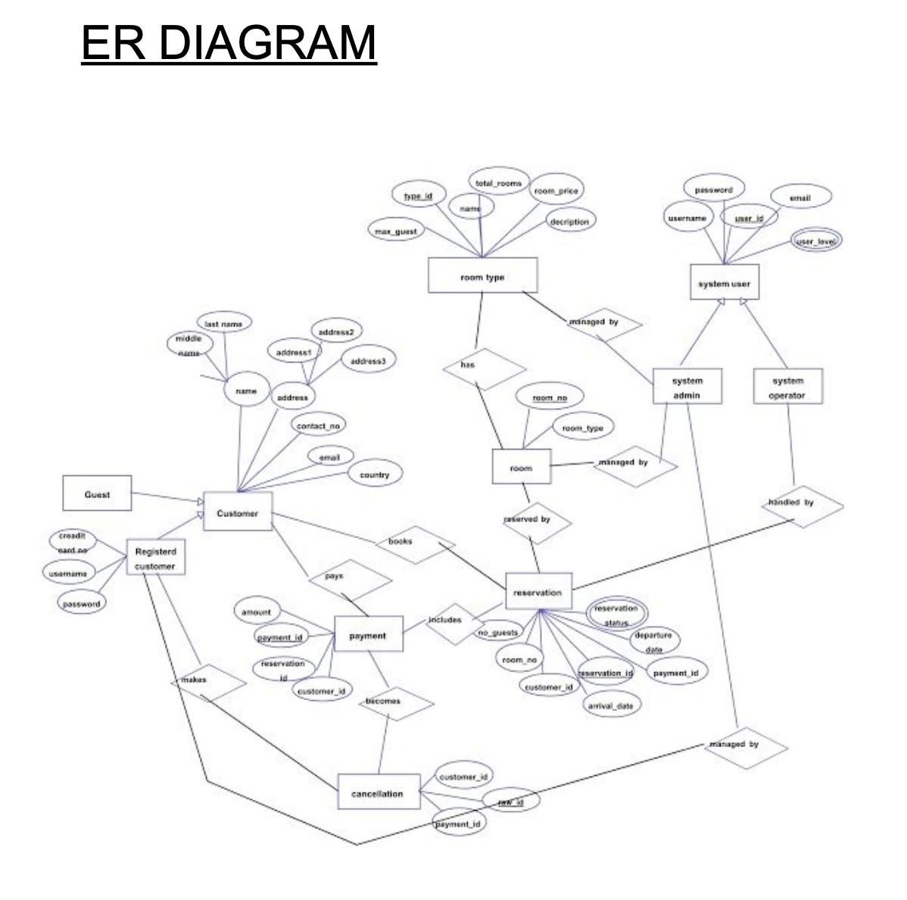

**2.Design of Relational Schemas, Creation of Database Tables for the project.**

* 1. Design of Relational Schemas

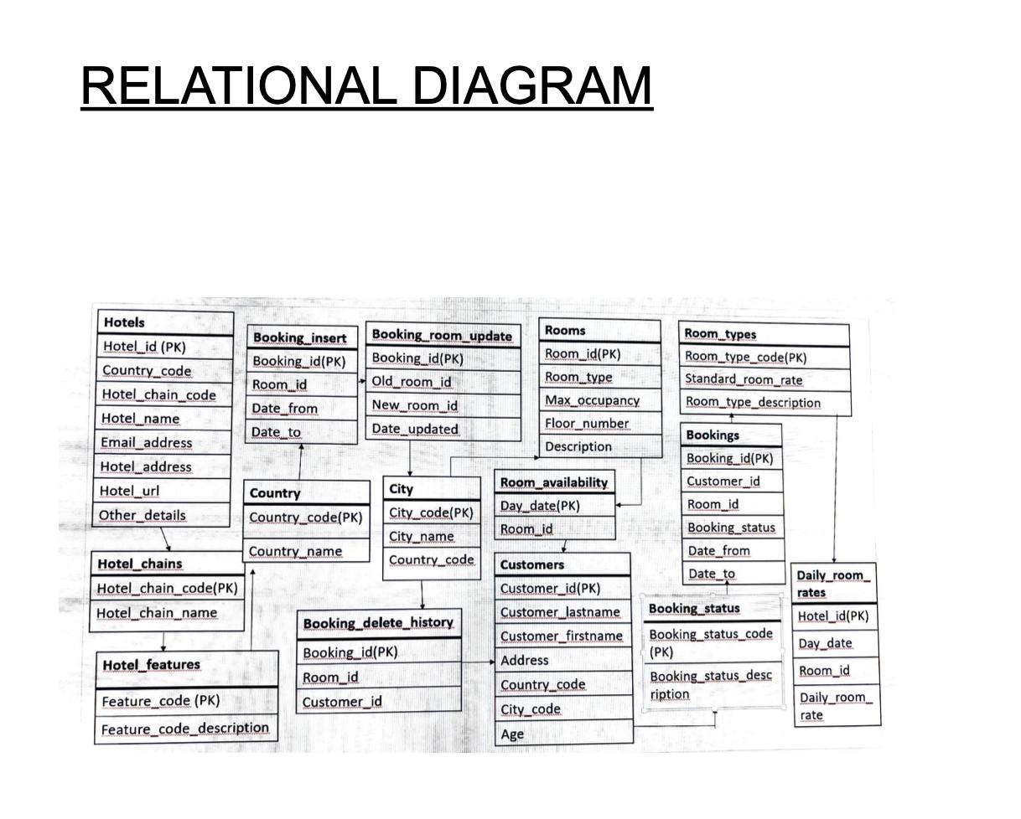

2.2 Creation of Database Tables for the project

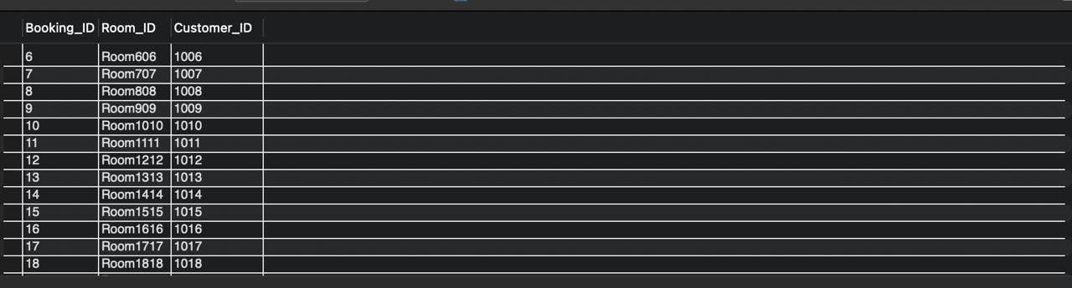

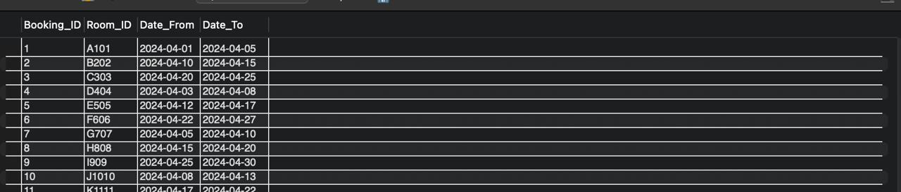

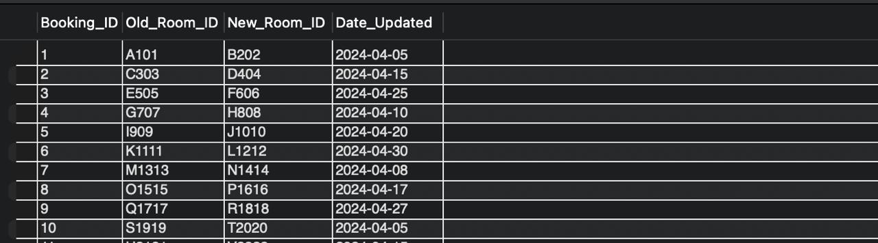

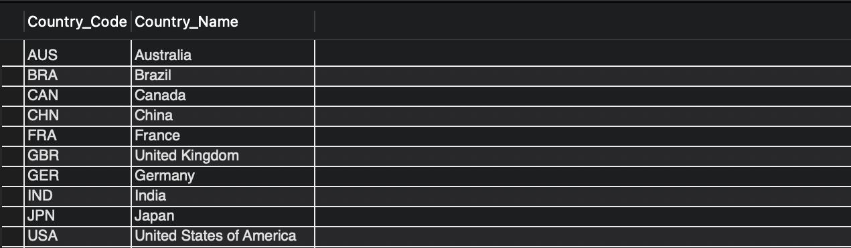

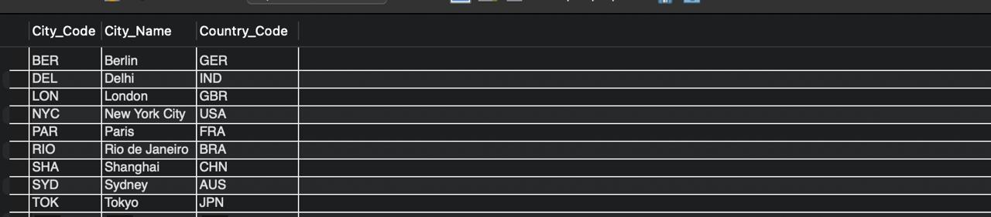

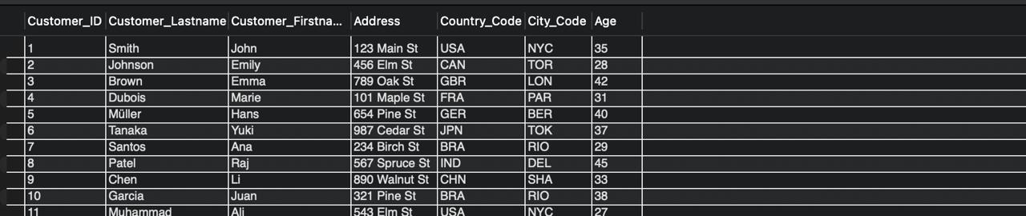

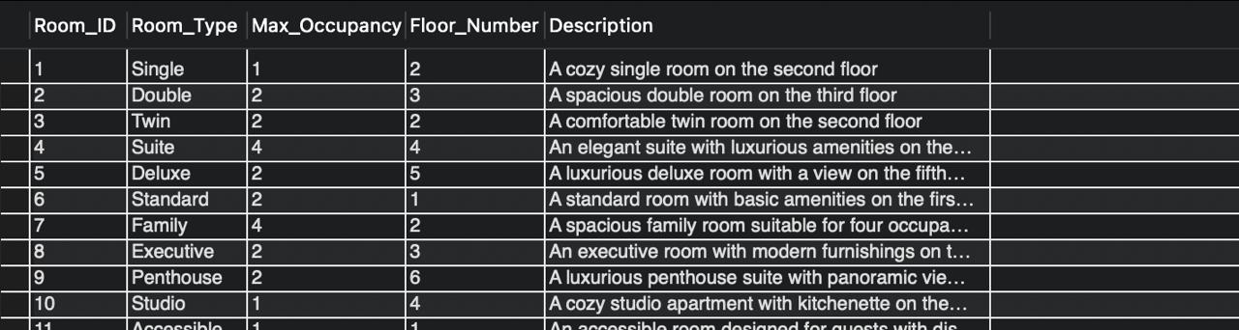

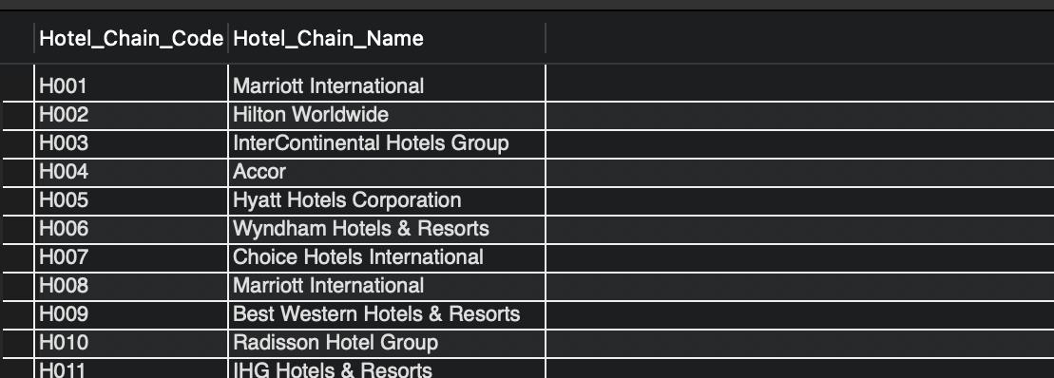

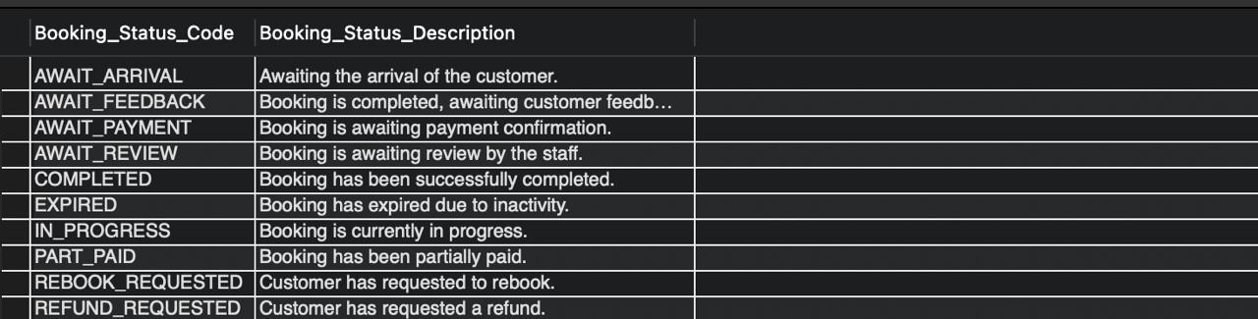

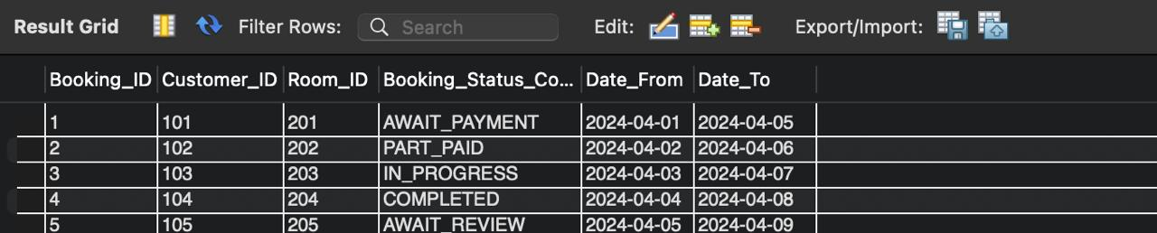

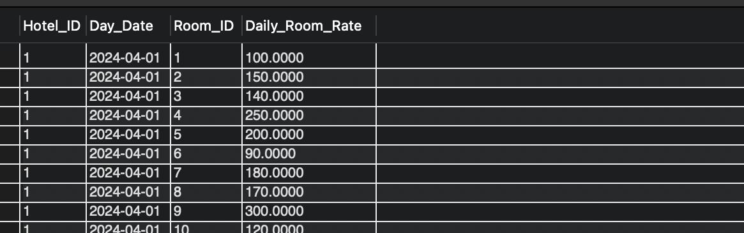

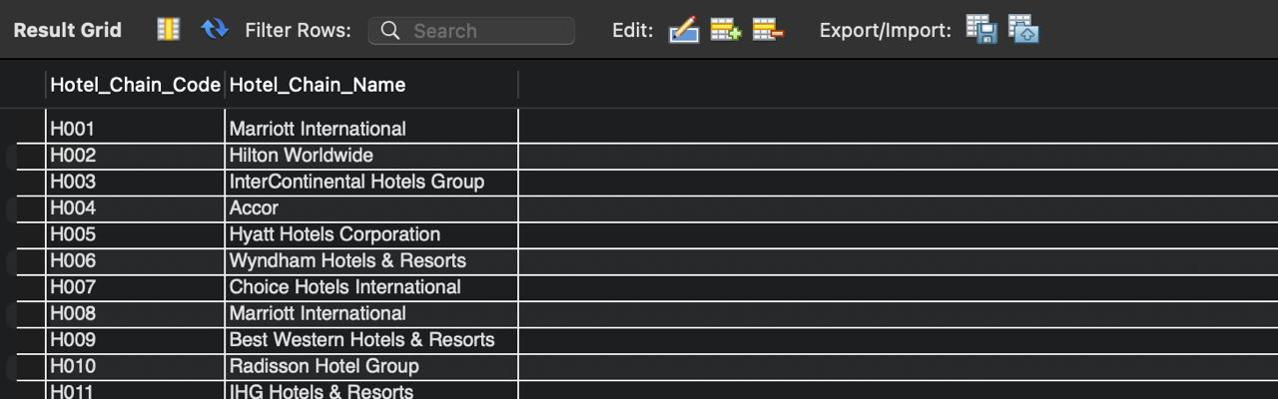

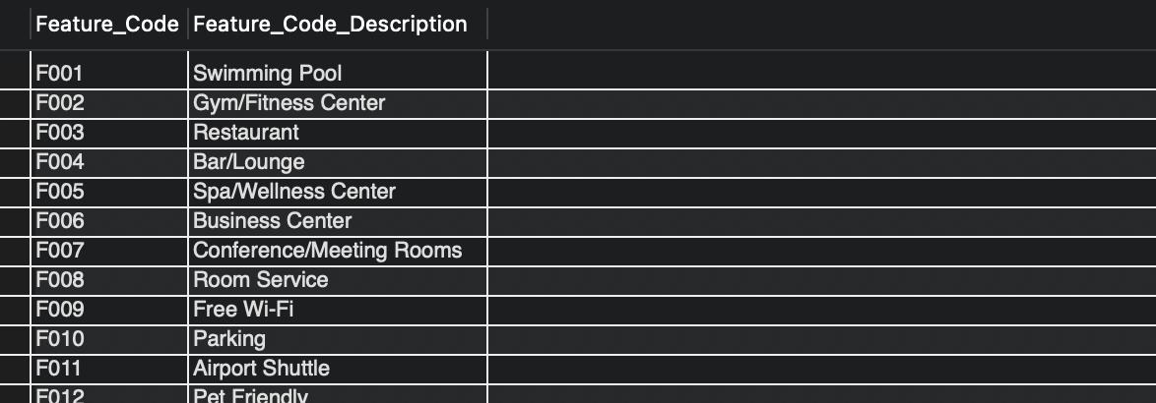

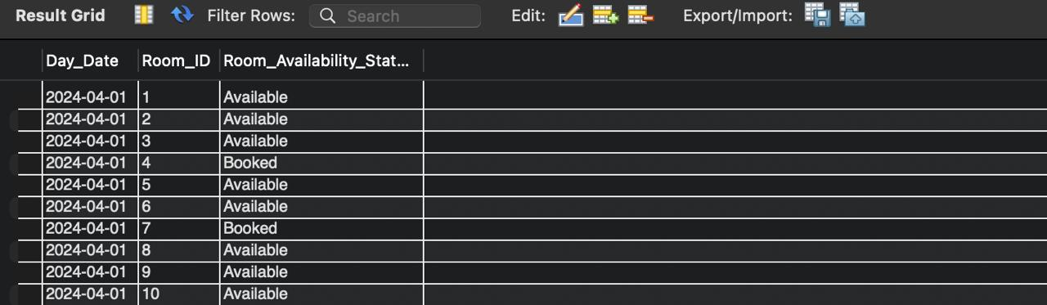

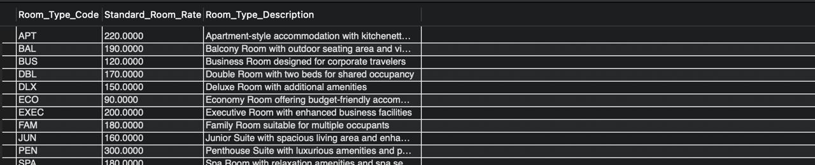

1. **Complex queries based on the concepts of constraints, sets, joins, views, Triggers and Cursors.**

**1. Constraints:**

**Query: Find all rooms that are currently available for booking.**

**SELECT \***

**FROM Room**

**WHERE RoomID NOT IN (**

**SELECT RoomID**

**FROM Reservation**

**WHERE CURRENT_DATE BETWEEN CheckInDate AND CheckOutDate**

**);**

**2. Sets:**

**Query: Find guests who have booked rooms in multiple hotels.**

**SELECT GuestID, COUNT(DISTINCT HotelID) AS NumHotelsBooked**

**FROM Reservation**

**GROUP BY GuestID**

**HAVING COUNT(DISTINCT HotelID) > 1;**

**3. Joins:**

**Query: Retrieve all reservations along with guest and hotel information.**

**SELECT r.ReservationID, g.Name AS GuestName, h.Name AS HotelName, r.CheckInDate, r.CheckOutDate**

**FROM Reservation r**

**JOIN Guest g ON r.GuestID = g.GuestID**

**JOIN Room rm ON r.RoomID = rm.RoomID**

**JOIN Hotel h ON rm.HotelID = h.HotelID;**

**4. Views:**

**Query: Create a view to display the total revenue generated by each hotel.**

**CREATE VIEW HotelRevenue AS**

**SELECT h.HotelID, h.Name AS HotelName, SUM(rm.Price) AS TotalRevenue**

**FROM Reservation r**

**JOIN Room rm ON r.RoomID = rm.RoomID**

**JOIN Hotel h ON rm.HotelID = h.HotelID**

**GROUP BY h.HotelID;**

**5. Triggers:**

**Scenario: Automatically update the room status when a reservation is made.**

**CREATE TRIGGER UpdateRoomStatus**

**AFTER INSERT ON Reservation**

**FOR EACH ROW**

**BEGIN**

**UPDATE Room**

**SET Status = 'Booked'**

**WHERE RoomID = NEW.RoomID;**

**END;**

**5. Triggers:**

**Scenario: Automatically update the room status when a reservation is made.**

**CREATE TRIGGER UpdateRoomStatus**

**AFTER INSERT ON Reservation**

**FOR EACH ROW**

**BEGIN**

**UPDATE Room**

**SET Status = 'Booked'**

**WHERE RoomID = NEW.RoomID;**

**END;**

**4.Analyzing the pitfalls, identifying the dependencies, and applying normalizations**

**1. Analyzing Pitfalls:**

**- **Data Redundancy**: Storing redundant data can lead to inconsistencies and increased storage requirements.**

**- **Update Anomalies**: Inefficient updates may result in inconsistencies if not properly managed.**

**- **Deletion Anomalies**: Removing data may unintentionally remove related information if dependencies are not handled correctly.**

**- **Insertion Anomalies**: Difficulties in inserting new data due to constraints or dependencies.**

**- **Data Integrity**: Ensuring data consistency and accuracy throughout the database.**

**2. Identifying Dependencies:**

**- **Functional Dependencies**: Determine which attributes depend on others within a table.**

**- **Transitive Dependencies**: Identify dependencies where an attribute depends on another through a third attribute.**

**- **Multi-valued Dependencies**: Recognize dependencies where one attribute determines multiple values of another.**

**3. Applying Normalizations:**

**- **First Normal Form (1NF)**:**

**- Eliminate repeating groups.**

**- Ensure each attribute contains atomic values.**

**- **Second Normal Form (2NF)**:**

**- Meet 1NF requirements.**

**- Remove partial dependencies by moving non-key attributes to separate tables.**

**- **Third Normal Form (3NF)**:**

**- Satisfy 2NF requirements.**

**- Eliminate transitive dependencies by moving non-key attributes to separate tables.**

**- **Boyce-Codd Normal Form (BCNF)**:**

**- Similar to 3NF but stricter in terms of dependency preservation.**

**- **Fourth Normal Form (4NF)**:**

**- Address multi-valued dependencies.**

**- **Fifth Normal Form (5NF)**:**

**- Address join dependencies.**

**Example of Applying Normalization:**

**Let's normalize the following table `Reservation`:**

**| ReservationID | GuestID | RoomID | CheckInDate | CheckOutDate |**

**|---------------|---------|--------|-------------|--------------|**

**| 1 | 101 | 201 | 2024-05-10 | 2024-05-15 |**

**| 2 | 102 | 202 | 2024-05-12 | 2024-05-18 |**

**| 3 | 101 | 203 | 2024-05-20 | 2024-05-25 |**

**\*\*First Normal Form (1NF)**:**

**- No repeating groups are present, so it's already in 1NF.**

**\*\*Second Normal Form (2NF)**:**

**- No partial dependencies, so it's already in 2NF.**

**\*\*Third Normal Form (3NF)**:**

**- There are no transitive dependencies, so it's already in 3NF.**

**\*\*Boyce-Codd Normal Form (BCNF)**:**

**- No further normalization needed as it's already in BCNF.**

**\*\*Fourth Normal Form (4NF)**:**

**- No multi-valued dependencies, so it's already in 4NF.**

**\*\*Fifth Normal Form (5NF)**:**

**- No join dependencies, so it's already in 5NF.**

**Dependencies Identified:**

**- `ReservationID` → `{GuestID, RoomID, CheckInDate, CheckOutDate}`**

**- `{GuestID, RoomID}` → `{CheckInDate, CheckOutDate}`**

**- `{RoomID}` → `{CheckInDate, CheckOutDate}`**

**By applying normalization techniques, we ensure data integrity, minimize redundancy, and avoid anomalies, thereby enhancing the efficiency and reliability of the hotel booking system database.**

1. **Implementation of concurrency control and recovery mechanisms**

Implementing concurrency control and recovery mechanisms is crucial for ensuring the integrity and consistency of data in a hotel booking system, especially in scenarios where multiple users may access and modify the database simultaneously. Here's how you can implement these mechanisms:

1. Concurrency Control:

a. Locking Mechanisms:

- **Two-Phase Locking (2PL)**: Acquire locks on data items before accessing them and release locks only after completing the transaction.

- **Timestamp Ordering**: Assign timestamps to transactions and allow them to access data based on their timestamps, ensuring serializability.

- **Optimistic Concurrency Control (OCC)**: Allow transactions to proceed without locking and check for conflicts before committing. Rollback transactions if conflicts are detected.

b. Isolation Levels:

- **Read Uncommitted**: Allows transactions to read uncommitted data.

- **Read Committed**: Only allows transactions to read committed data.

- **Repeatable Read**: Ensures a transaction sees the same data throughout its execution.

- **Serializable**: Ensures that transactions are executed as if they were serialized.

2. Recovery Mechanisms:

a. Logging:

- **Write-Ahead Logging (WAL)**: Log changes to the database before writing them, ensuring that the log is written before the actual data.

- **Redo Log**: Record changes made to the database, allowing for recovery in case of failure by replaying the log to redo changes.

- **Undo Log**: Record the before-image of data items modified by transactions, allowing for rollback in case of failure by applying undo operations.

b. Checkpoints:

- **Periodic Checkpoints**: Periodically write a snapshot of the database to stable storage, reducing the amount of redo and undo logs needed for recovery.

- **Fuzzy Checkpoints**: Allow transactions to continue executing during checkpointing, ensuring minimal downtime.

Implementation Steps:

1. **Design Logging and Recovery Modules**:

- Implement logging mechanisms to record changes made by transactions.

- Design recovery algorithms to ensure database consistency in case of failure.

2. **Implement Locking Mechanisms**:

- Integrate locking mechanisms such as 2PL or timestamp ordering to manage concurrent access to data.

3. **Define Isolation Levels**:

- Implement isolation levels to control the visibility of data changes to transactions.

4. **Handle Deadlocks**:

- Implement deadlock detection and resolution mechanisms to prevent transactional deadlocks.

5. **Test and Tune**:

- Thoroughly test the concurrency control and recovery mechanisms under various scenarios to ensure correctness and performance.

- Fine-tune parameters such as checkpoint intervals and lock escalation policies based on system performance.

6. **Monitor and Maintain**:

- Regularly monitor system performance and tune concurrency control mechanisms as needed.

- Ensure regular backups and periodic testing of recovery procedures to maintain data integrity.

By implementing robust concurrency control and recovery mechanisms, you can ensure the reliability, consistency, and availability of the hotel booking system, even in the face of concurrent transactions and system failures.

1. **Code for the project**

-- phpMyAdmin SQL Dump

-- version 4.8.4

-- https://www.phpmyadmin.net/

--

-- Host: 127.0.0.1

-- Generation Time: Oct 10, 2020 at 06:23 AM

-- Server version: 10.1.37-MariaDB

-- PHP Version: 5.6.39

SET SQL_MODE = "NO_AUTO_VALUE_ON_ZERO";

SET AUTOCOMMIT = 0;

START TRANSACTION;

SET time_zone = "+00:00";

/*!40101 SET @OLD_CHARACTER_SET_CLIENT=@@CHARACTER_SET_CLIENT */;

/*!40101 SET @OLD_CHARACTER_SET_RESULTS=@@CHARACTER_SET_RESULTS */;

/*!40101 SET @OLD_COLLATION_CONNECTION=@@COLLATION_CONNECTION */;

/*!40101 SET NAMES utf8mb4 */;

--

-- Database: `sourcecodester_hoteldb`

--

-- --------------------------------------------------------

--

-- Table structure for table `contact`

--

CREATE TABLE `contact` (

`id` int(10) UNSIGNED NOT NULL,

`fullname` varchar(100) DEFAULT NULL,

`phoneno` int(10) DEFAULT NULL,

`email` text,

`cdate` date DEFAULT NULL,

`approval` varchar(12) DEFAULT NULL

) ENGINE=InnoDB DEFAULT CHARSET=latin1;

-- --------------------------------------------------------

--

-- Table structure for table `login`

--

CREATE TABLE `login` (

`id` int(10) UNSIGNED NOT NULL,

`usname` varchar(30) DEFAULT NULL,

`pass` varchar(30) DEFAULT NULL

) ENGINE=InnoDB DEFAULT CHARSET=latin1;

--

-- Dumping data for table `login`

--

INSERT INTO `login` (`id`, `usname`, `pass`) VALUES

(1, 'janobe', 'janobe');

-- --------------------------------------------------------

--

-- Table structure for table `newsletterlog`

--

CREATE TABLE `newsletterlog` (

`id` int(10) UNSIGNED NOT NULL,

`title` varchar(52) DEFAULT NULL,

`subject` varchar(100) DEFAULT NULL,

`news` text

) ENGINE=InnoDB DEFAULT CHARSET=latin1;

--

-- Dumping data for table `newsletterlog`

--

INSERT INTO `newsletterlog` (`id`, `title`, `subject`, `news`) VALUES

(1, 'asd', 'Send me an Email', 'asd');

-- --------------------------------------------------------

--

-- Table structure for table `payment`

--

CREATE TABLE `payment` (

`id` int(11) DEFAULT NULL,

`title` varchar(5) DEFAULT NULL,

`fname` varchar(30) DEFAULT NULL,

`lname` varchar(30) DEFAULT NULL,

`troom` varchar(30) DEFAULT NULL,

`tbed` varchar(30) DEFAULT NULL,

`nroom` int(11) DEFAULT NULL,

`cin` date DEFAULT NULL,

`cout` date DEFAULT NULL,

`ttot` double(8,2) DEFAULT NULL,

`fintot` double(8,2) DEFAULT NULL,

`mepr` double(8,2) DEFAULT NULL,

`meal` varchar(30) DEFAULT NULL,

`btot` double(8,2) DEFAULT NULL,

`noofdays` int(11) DEFAULT NULL

) ENGINE=InnoDB DEFAULT CHARSET=latin1;

--

-- Dumping data for table `payment`

--

INSERT INTO `payment` (`id`, `title`, `fname`, `lname`, `troom`, `tbed`, `nroom`, `cin`, `cout`, `ttot`, `fintot`, `mepr`, `meal`, `btot`, `noofdays`) VALUES

(2, 'Dr.', 'janobe', 'janobe', 'Superior Room', 'Single', 1, '2020-10-10', '2020-10-11', 320.00, 323.20, 0.00, 'Room only', 3.20, 1);

-- --------------------------------------------------------

--

-- Table structure for table `room`

--

CREATE TABLE `room` (

`id` int(10) UNSIGNED NOT NULL,

`type` varchar(15) DEFAULT NULL,

`bedding` varchar(10) DEFAULT NULL,

`place` varchar(10) DEFAULT NULL,

`cusid` int(11) DEFAULT NULL

) ENGINE=InnoDB DEFAULT CHARSET=latin1;

--

-- Dumping data for table `room`

--

INSERT INTO `room` (`id`, `type`, `bedding`, `place`, `cusid`) VALUES

(1, 'Superior Room', 'Single', 'Free', 0),

(2, 'Superior Room', 'Double', 'Free', NULL),

(3, 'Superior Room', 'Triple', 'Free', NULL),

(4, 'Single Room', 'Quad', 'Free', NULL),

(5, 'Superior Room', 'Quad', 'Free', NULL),

(6, 'Deluxe Room', 'Single', 'Free', NULL),

(7, 'Deluxe Room', 'Double', 'Free', NULL),

(8, 'Deluxe Room', 'Triple', 'Free', NULL),

(9, 'Deluxe Room', 'Quad', 'Free', NULL),

(10, 'Guest House', 'Single', 'Free', NULL),

(11, 'Guest House', 'Double', 'Free', NULL),

(12, 'Guest House', 'Quad', 'Free', NULL),

(13, 'Single Room', 'Single', 'Free', NULL),

(14, 'Single Room', 'Double', 'Free', NULL),

(15, 'Single Room', 'Triple', 'Free', NULL);

-- --------------------------------------------------------

--

-- Table structure for table `roombook`

--

CREATE TABLE `roombook` (

`id` int(10) UNSIGNED NOT NULL,

`Title` varchar(5) DEFAULT NULL,

`FName` text,

`LName` text,

`Email` varchar(50) DEFAULT NULL,

`National` varchar(30) DEFAULT NULL,

`Country` varchar(30) DEFAULT NULL,

`Phone` text,

`TRoom` varchar(20) DEFAULT NULL,

`Bed` varchar(10) DEFAULT NULL,

`NRoom` varchar(2) DEFAULT NULL,

`Meal` varchar(15) DEFAULT NULL,

`cin` date DEFAULT NULL,

`cout` date DEFAULT NULL,

`stat` varchar(15) DEFAULT NULL,

`nodays` int(11) DEFAULT NULL

) ENGINE=InnoDB DEFAULT CHARSET=latin1;

--

-- Indexes for dumped tables

--

--

-- Indexes for table `contact`

--

ALTER TABLE `contact`

ADD PRIMARY KEY (`id`);

--

-- Indexes for table `login`

--

ALTER TABLE `login`

ADD PRIMARY KEY (`id`);

--

-- Indexes for table `newsletterlog`

--

ALTER TABLE `newsletterlog`

ADD PRIMARY KEY (`id`);

--

-- Indexes for table `room`

--

ALTER TABLE `room`

ADD PRIMARY KEY (`id`);

--

-- Indexes for table `roombook`

--

ALTER TABLE `roombook`

ADD PRIMARY KEY (`id`);

--

-- AUTO_INCREMENT for dumped tables

--

--

-- AUTO_INCREMENT for table `contact`

--

ALTER TABLE `contact`

MODIFY `id` int(10) UNSIGNED NOT NULL AUTO_INCREMENT;

--

-- AUTO_INCREMENT for table `login`

--

ALTER TABLE `login`

MODIFY `id` int(10) UNSIGNED NOT NULL AUTO_INCREMENT, AUTO_INCREMENT=3;

--

-- AUTO_INCREMENT for table `newsletterlog`

--

ALTER TABLE `newsletterlog`

MODIFY `id` int(10) UNSIGNED NOT NULL AUTO_INCREMENT, AUTO_INCREMENT=2;

--

-- AUTO_INCREMENT for table `room`

--

ALTER TABLE `room`

MODIFY `id` int(10) UNSIGNED NOT NULL AUTO_INCREMENT, AUTO_INCREMENT=16;

--

-- AUTO_INCREMENT for table `roombook`

--

ALTER TABLE `roombook`

MODIFY `id` int(10) UNSIGNED NOT NULL AUTO_INCREMENT, AUTO_INCREMENT=3;

COMMIT;

/*!40101 SET CHARACTER_SET_CLIENT=@OLD_CHARACTER_SET_CLIENT */;

/*!40101 SET CHARACTER_SET_RESULTS=@OLD_CHARACTER_SET_RESULTS */;

/*!40101 SET COLLATION_CONNECTION=@OLD_COLLATION_CONNECTION */;

1. **Result and Discussion**

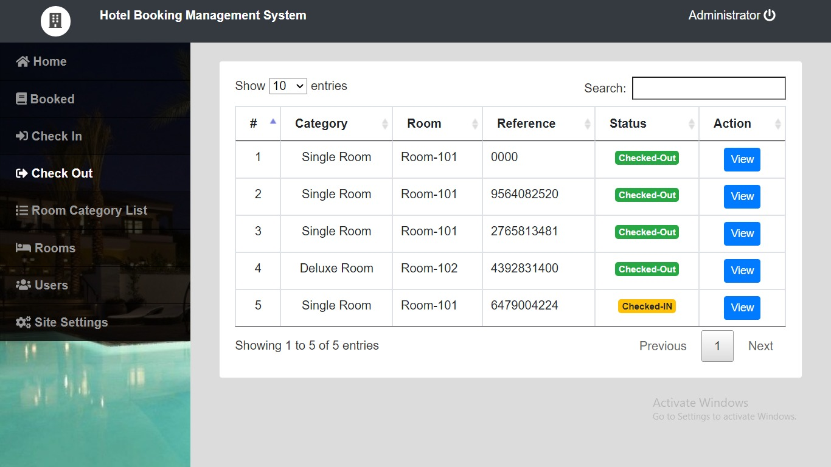

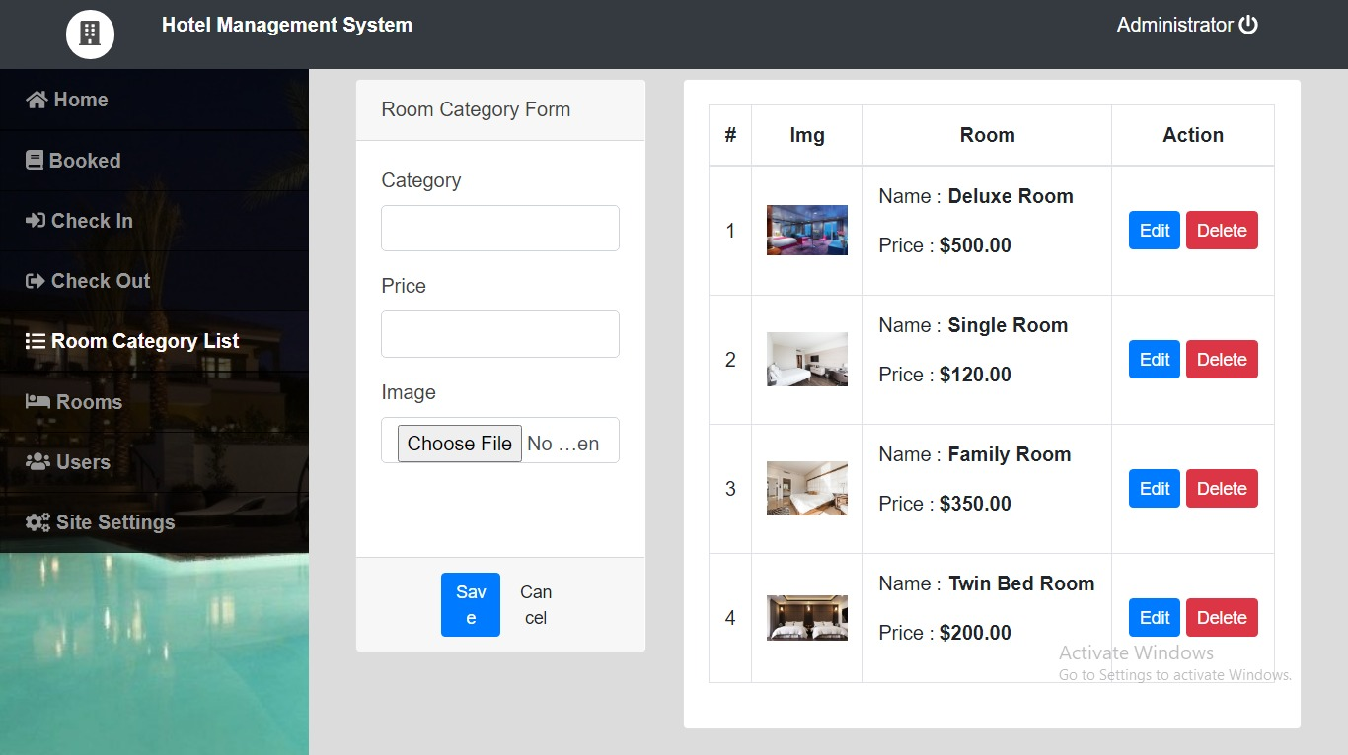

1. Streamlined Booking Process:

Enhanced User Experience: Hotel booking systems provide a user-friendly interface for guests to search for accommodations, view room availability, and make reservations seamlessly.

Convenience: Guests can book rooms at their preferred hotels anytime, anywhere, using various devices such as smartphones, tablets, or computers, offering unmatched convenience.

2. Operational Efficiency:

Centralized Management: Hotel booking systems enable hoteliers to manage room inventory, rates, and bookings from a centralized platform, streamlining operations and reducing the likelihood of overbooking or double bookings.

Automation: Automation of booking processes, including confirmation emails, payment processing, and room assignment, saves time and minimizes manual errors.

3. Revenue Optimization:

Dynamic Pricing: Hotel booking systems allow hoteliers to implement dynamic pricing strategies based on demand, seasonality, and other factors, maximizing revenue potential.

Upselling Opportunities: Integrated systems can suggest room upgrades, additional services, or special packages during the booking process, increasing revenue per guest.

4. Data Insights and Personalization:

Analytics: Hotel booking systems capture valuable data on booking trends, guest preferences, and revenue performance, enabling data-driven decision-making and targeted marketing efforts.

Personalization: By analyzing guest data, hotels can personalize the booking experience with tailored recommendations, loyalty rewards, and customized promotions, fostering guest loyalty and satisfaction.

5. Security and Trust:

Secure Transactions: Implementing robust security measures, such as encryption protocols and PCI compliance, ensures the confidentiality and integrity of guests' payment information, building trust and credibility.

Data Privacy: Hotel booking systems adhere to data privacy regulations, such as GDPR, by obtaining consent for data processing and providing transparent privacy policies, safeguarding guests' personal information.

1. **Online Course Certificate**

**RA2211026010443**



**RA2211026010393**

